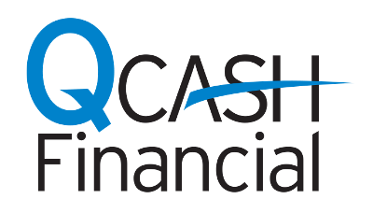
NEWS RELEASE

MEDIA CONTACT:
Jenny Matthews
QCash Financial
800.893.7893 x10475
jmatthews@q-cash.com

Freedom First selects QCash Financial to provide payday loan alternative

Provides credit union members more affordable option for small-dollar loans

Olympia, Wash., August 6, 2018 – QCash Financial, a provider of automated, cloud-based, small-dollar lending technology, today announced that it is partnering with Freedom First Credit Union to offer short-term, small-dollar payday loan alternatives to credit union members through its QCash product.
Using QCash Financial’s product suite, Freedom First can offer an affordable lending option to members who otherwise might rely on costly services like traditional payday loans to cover unexpected expenses. QCash is an automated digital lending platform and uses the member’s financial history with the financial institution to underwrite, approve and fund the loan in under one minute. The fees and rates associated with QCash loans are substantially below those charged by traditional short-term lenders.
“Our mission at Freedom First is helping people prosper – helping communities thrive. And we measure our value by how much we give back,” said Dave Prosser, Freedom First’s Senior Vice President of Community Development. “We take pride in meeting our members’ needs right where they are on their financial journey, whether they are just starting out or they need money management options during more challenging times. QCash Financial’s automated solution is simple, fast, and bases underwriting decisions on the member’s relationship with us, not a credit score.”
“Freedom First understands how important access to cash is for breaking the cycle of debt and attaining financial stability,” said Ben Morales, CEO of QCash Financial. “Small-dollar loans offer better rates and terms. Delivering cash quickly to members can be a powerful step in moving members toward improved financial health. Freedom First looks out for those communities that need their services the most and we’re proud to be a partner with them.”
The QCash loan platform was developed in 2004 by WSECU after the credit union’s tellers noticed a substantial number of its members required small, short-term loans from pay day lenders that were charging excessive fees and interest rates. It is offered as a white label solution to financial institutions. For more information, contact Ben Morales at bmorales@q-cash.com.

About Freedom First Credit Union
Freedom First Credit Union has more than 52,000 members and $533 million in assets and is headquartered in the Roanoke, Virginia. With 10 branches in Roanoke and New River Valleys, Freedom First is creating local economic vitality through their core impact banking programs for affordable housing, transportation, financial education, impact banking, and community revitalization. Learn more about Impact Services.

About QCash Financial
QCash Financial is a CUSO providing automated, cloud-based, omni-channel lending technology that enables financial institutions to provide short-term loans quickly to the people they serve. QCash Financial, a wholly-owned subsidiary of WSECU in Olympia, Wash., started as a short-term loan solution for the credit union’s members in 2004. For more information about QCash, visit Q-Cash.com

