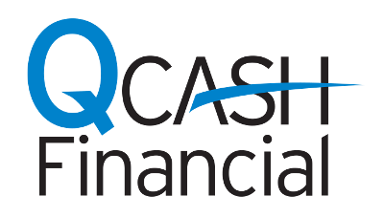
NEWS RELEASE

MEDIA CONTACT:
Jenny Matthews
QCash Financial
800.893.7893 x10475
jmatthews@qcashfinancial.com

Hudson Valley Federal Credit Union Now Offering Short-Term,
Small Dollar Loans Powered by QCash Financial

Provides credit union members a more affordable lending option

Olympia, Wash., February 25, 2019 - QCash Financial, a provider of automated, cloud-based, small-dollar lending technology, has partnered with Hudson Valley Federal Credit Union to offer a short-term, small-dollar loan alternative to credit union members through its QCash product.

Using QCash Financial’s product suite, Hudson Valley now offers A Personal Assistance Loan for members who need a little extra cash for books, groceries, an emergency car repair, or anything in between. QCash is an automated digital lending platform and uses the member’s financial history with the credit union to underwrite, approve, and fund the loan in under one minute. The fees and rates associated with QCash loans are configurable by each credit union and typically substantially below those charged by traditional short-term lenders.

HVFCU’s Personal Assistance Loan has taken the market by storm. “We’re thrilled with members’ response to this new product. We are achieving our goal to offer members an affordable alternative to other payday loan options. Delivering cash quickly to members can be a powerful step in moving them toward improved financial health,” said Brian Waldron, Senior Vice President of Lending for HVFCU. “QCash Financial’s solution is simple and enables us to pass on savings to our members.”

“Hudson Valley Federal Credit Union has expanded its personal loan offering to capture member emergency liquidity needs when everyday life happens. The quick availability of these loans improve members’ financial stability,” said Ben Morales, CEO of QCash Financial. “Our automated solution is fully configurable to offer better rates and terms. The loan progresses from application to funding in less than 60 seconds. Hudson Valley looks out for those communities that need their services the most and we’re proud to be a partner with them.”

About Hudson Valley Credit Union
With more than 287,000 members and $4.8 billion in assets, Hudson Valley Federal Credit Union is headquartered in the Poughkeepsie, NY. With 19 branches across the state of New York, HVFCU is a community-based financial cooperative committed to strengthening the quality of life for their members, friends, families, and neighbors in the Hudson Valley. For more than fifty years, it has been their mission to provide affordable products and convenient services to help members succeed financially through every stage of life.

About QCash Financial
QCash Financial is a CUSO providing automated, cloud-based, omni-channel lending technology that enables financial institutions to provide short-term loans quickly to the people they serve. QCash Financial, a wholly-owned subsidiary of WSECU in Olympia, Wash., started as a short-term loan solution for the credit union’s members in 2004. For more information about QCash, visit QCashFinancial.com or contact Ben Morales at bmorales@qcashfinancial.com

