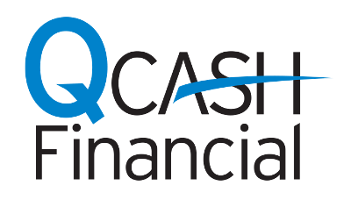
NEWS RELEASE

MEDIA CONTACT:
Ann Flannigan
Q-Cash/WSECU
360.754.6138
aflannigan@wsecu.org

IHMVCU taps Q-Cash Financial to provide payday loan alternative

Provides credit union members more affordable option for small-dollar loans

Olympia, Wash., Jan. 17, 2018 – QCash Financial, a provider of automated, cloud-based, small-dollar lending technology, today announced that it is partnering with I.H. Mississippi Valley Credit Union (IHMVCU) to offer short-term, small-dollar pay loan alternatives to credit union members through its QCash product.
Using QCash Financial’s product suite, IHMVCU can offer an affordable lending option to members who otherwise might rely on costly services like traditional payday loans to cover unexpected expenses. QCash is an automated digital lending platform and uses the member’s financial history with the financial institution to underwrite, approve and fund the loan in under one minute. The fees and rates associated with QCash loans are substantially below those charged by traditional short-term lenders.
“We take pride in meeting our members’ needs right where they are on their financial journey, whether they are just starting out or they need money management options during more challenging times,” said Lisa Olson, Chief Risk Officer for IHMVCU. “QCash Financial’s automated solution is simple, fast, and bases underwriting decisions on the member’s relationship with us, not a credit score.”
“IHMVCU understands how important access to cash is for financial stability,” said Ben Morales, CEO of QCash Financial. “Small-dollar loans offered at better rates and terms and delivered quickly can be a powerful tool in the credit union toolbox to help members. IHMVCU looks out for those communities that need their services the most and we’re proud to be a partner with them.”
The QCash loan platform was developed in 2004 by WSECU after the credit union’s tellers noticed a substantial number of its members required small, short-term loans from payday lenders that were charging excessive fees and interest rates. It is offered as a white label solution to financial institutions. For more information, contact Ben Morales at bmorales@q-cash.com.

About IH Mississippi Valley Credit Union
IH Mississippi Valley Credit Union (IHMVCU) has more than 120,000 members and $1.2 billion in assets and is the fifth-largest credit union in Illinois. With 17 branches in eastern Iowa and western Illinois, and a progressive and growing online branch, IHMVCU’s path-finding employees provide convenient financial solutions catered to each member-owner’s journey to financial success.

About QCash Financial
QCash Financial is a CUSO providing automated, cloud-based, omni-channel lending technology that enables financial institutions to provide short-term loans quickly to the people they serve. QCash Financial, a wholly-owned subsidiary of WSECU in Olympia, Wash., started as a short-term loan solution for the credit union’s members in 2004. For more information about QCash, visit its website at Q-Cash.com
#

