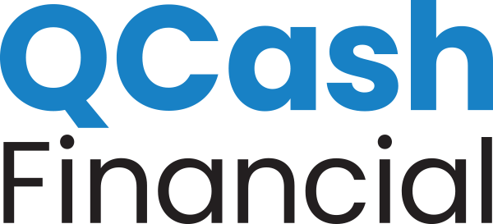

NEWS RELEASE

MEDIA CONTACT:
Erika Taylor Montgomery, Erika@ThreeGirlsMedia.com

Billings Federal Credit Union short-term loans, powered by QCash Financial’s platform, are providing a fast way for members to handle emergency expenses

Olympia, Wash., February 2, 2021 – Headquartered in Billings, Montana, Billings Federal Credit Union (BFCU) launched a new small dollar loan product on November 30th, 2020. QCash is a short-term loan ranging from $250 to $1,000 that helps members deal with unexpected cash needs in an easy to use, mobile application process.

Using QCash Financial’s white-label, digital small dollar lending platform, BFCU automated the loan process using the member’s credit union relationship history to make the lending decision rather than credit history. Members learn immediately what they qualify for, and the funds are deposited into their account right away. The fees and rates are configurable by each financial institution and are substantially lower than predatory, short-term lenders.

“One of our member promises is to simplify their lives,” said BFCU President/CEO, Tom Boos. “These small dollar loans align with this promise. A member can apply for a QCash loan from anywhere, 24 hours a day, seven days a week if they have access to the internet. And if approved, their funds are available almost instantaneously. It doesn’t get much easier than that,” Boos said.

In addition to an easy loan application process, the QCash Financial platform provides short-term liquidity to members who historically turned to high-cost lending sources, such as payday lenders or pawn shops with triple-digit APRs. Bad credit limits consumer options when cash is needed. Predatory lenders are often the only option unless credit unions provide a responsible, affordable alternative. The need for small dollar loans like QCash has grown as a result of the pandemic.

“As we move from economic relief toward recovery and stability, credit unions recognize the pandemic increased financial hardships for many. Financial inclusion is top of mind for innovative credit unions as they look for ways to help those hardest hit. Credit unions, like BFCU, are providing a needed resource to their communities,” said QCash Financial CEO, Ben Morales.

Additionally, “Federal regulators are encouraging credit unions to offer small dollar loans which rescue members from a cycle of debt that’s hard to escape,” Morales said. “Once the immediate need has been met, members with improved financial health can move upstream to utilize other traditional credit union resources.”

About Billings Federal Credit Union
Billings Federal Credit Union (BFCU) serves 11,200 members and has more than $180M in member-owned assets. Established in 1935, BFCU is a not-for-profit cooperative, owned by its membership. Anyone who lives, works, worships or attends school in Yellowstone, Big Horn or Carbon Counties, Montana is eligible to become a member. BFCU offers a full line of financial products and services, competitive rates and low fees, and personal, professional services from staff members.

About QCash Financial
QCash Financial, headquartered in Olympia, WA, is a purpose-driven FinTech firm with a mission of empowering financial institutions in their quest to improve the financial wellness of their communities. QCash Financial offers an automated, cloud-based, short-term lending technology and is currently piloting a financial wellness app with existing clients designed to build financial capacity, stability, and resilience.

###

