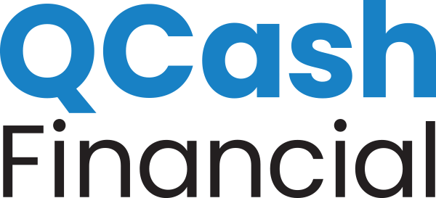
NEWS RELEASE

MEDIA CONTACT:

Lyndi Malley
Lyndi@ThreeGirlsMedia.com
425-471-8631

Erika Montgomery
Erika@ThreeGirlsMedia.com
408-218-2391

Jax Federal Credit Union Provides New Resources for Members by Offering Affordable Short-term Loans, Powered by the QCash Financial Lending Platform

Olympia, Wash., December 16, 2020 – Headquartered in Jacksonville, Florida, Jax Federal Credit Union (JAXFCU) has launched a new small dollar loan product called QCash, offering short-term loans up to $2,000, helping members with their unexpected cash needs. The digital application is easy to use, utilizing at least 6 months of the member’s credit union financial history to underwrite, approve, and fund the loan in less than 60 seconds.

Using QCash Financial’s white-label, digital lending platform, JAXFCU has automated loan processing using the member’s credit union relationship to make the lending decision rather than the member’s credit score history. Members immediately learn what they qualify for, and the funds are deposited into their account right away. Rates are configurable by JAXFCU and are substantially lower than traditional short-term predatory lenders. JAXFCU notes that QCash loans are a great way to get a little extra cash for college, groceries, or an emergency car repair. Additionally, QCash loans can help build or repair credit and are a smart, responsible alternative to high-interest loans.

“One of our member initiatives is to provide products and services which help members achieve financial wellness,” said Joy Bing, Director of Lending Operations JAXFCU. “We wanted to improve affordable access to cash for members facing unexpected expenses. These loans support our efforts to empower members who don’t qualify for traditional credit resources.”

“JAXFCU understands that being there for their members includes offering responsible lending products to manage the surprises life hands all of us,” said Ben Morales, QCash Financial CEO. “We’re pleased to partner with the JAXFCU team to positively impact members’ lives, providing help when they need it most.”

About Jax Federal Credit Union
Jax Federal Credit Union is headquartered in Jacksonville, Florida, serving over 39,000 members and over $404M in member-owned assets. Initially established in 1935 and currently serving anyone who lives, works, goes to school, or worships in the following Northeast Florida counties of Duval, Clay, Nassau, baker, and St. Johns.

About QCash Financial
QCash Financial, headquartered in Olympia, WA, is a purpose-driven FinTech firm with a mission of empowering financial institutions in their quest to improve the financial wellness of their communities. QCash Financial offers an automated, cloud-based, short-term lending technology and has recently launched a financial wellness app designed to build financial capacity, stability, and resilience.

