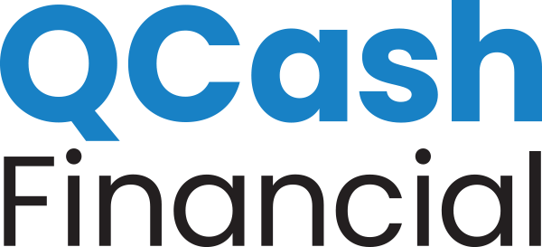

FOR IMMEDIATE RELEASE

MEDIA CONTACTS:
Lyndi Malley, Lyndi@ThreeGirlsMedia.com (425) 471-8631
Erika Taylor Montgomery, Erika@ThreeGirlsMedia.com (408) 218-2391

Oregon Community Credit Union, Powered By QCash Financial’s Platform, Offers Members Small Dollar Loans

New Offering Is A Fast And Convenient Path To Borrow Up To $4,000

Olympia, Wash., (September 1, 2020) Headquartered in Eugene, Oregon, Oregon Community Credit Union (OCCU) has launched a small dollar loan product called Priority Cash, offering short-term loans from $200 to $4,000. This product is designed to help members deal with unexpected cash needs with an easy-to-use digital banking solution.

Using QCash Financial’s white-label digital lending platform, OCCU automates the loan decision using data from its core banking system, rather than using credit bureau data. Members learn immediately what they qualify for, and the funds are deposited into their account in near real-time. The fees and rates are configurable by each financial institution and are substantially lower than traditional short-term lenders.

“Our values guide us at OCCU, and this product fits into our vision of enriching lives,” said Russ Bernardo, Chief Lending Officer at OCCU. “These small dollar loans provide our members with a quick and easy way to access liquidity when they need it. This is more important than ever right now, with COVID-19 impacting the financial situations of so many people.”

In addition to providing an easy application process, the QCash Financial platform also offers short-term funding for members who may have historically turned to high-cost lending sources, such as payday lenders or pawn shops with triple-digit APRs. In Oregon, lenders can charge an APR as high as 156% on a $100, 31-day loan.

“We know consumers are struggling right now. Having access to an affordable, small dollar loan is vital for millions of Americans — particularly during times of stress,” said QCash Financial CEO, Ben Morales. “We’re pleased to be working with credit unions like OCCU to help them provide a responsible safety net for their members.”

About OCCU
OCCU was founded in 1956 in Eugene, Oregon. Today, as a not-for-profit financial cooperative, OCCU has more than $2.3 billion in assets. Its members are served through digital channels and ten branch and service center locations in Eugene, Springfield, Salem, and Wilsonville. Although most members reside in one of the 28 Oregon counties or six Washington counties OCCU serves, others reside throughout the United States and even abroad, keeping their membership active through online and mobile banking. Learn more at MyOCCU.org.

About QCash Financial
QCash Financial, headquartered in Olympia, WA, is a purpose-driven FinTech firm with a mission of empowering financial institutions in their quest to improve the financial wellness of their communities. QCash Financial offers an automated, cloud-based, short-term lending technology and is currently piloting a financial wellness app with existing clients designed to build financial capacity, stability, and resilience.

