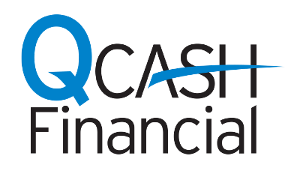
NEWS RELEASE

MEDIA CONTACT:
Misty Ford
QCash Financial
253-363-1317
mford@qcashfinancial.com

QCash Financial Announces New Client: Tropical Financial Credit Union

Enhancing member experience with instant approval personal loans

Olympia, Wash., February 21, 2020 – QCash Financial announces the signing of our newest client, Tropical Financial Credit Union (TFCU), headquartered in Miramar, Florida, with $700 million in assets. TFCU has retained QCash Financial to help them launch a small dollar, personal lending program for their more than 65,000 members. This product is designed to help their members deal with unexpected cash needs with a mobile-friendly and instantaneous application process.

“We know when our members need a personal loan they don’t expect the process to take very long. The member experience is paramount in everything we do and the employee experience is just as important,” said Keith Troup, TFCU Chief Lending Officer.

“Our partnership with QCash Financial will help satisfy the quick turnaround time needs of our members on their personal loan request. Furthermore, we’re creating back office efficiencies for the staff given it’s a completely automated, digital solution. We’re really looking forward to being able to serve more members in a shorter period of time with this partnership,” Troup added.

In 2019, the Federal Reserve released a study reporting roughly 40 percent of Americans are unable to cover a $400 emergency expense. The majority of these people have nowhere to turn.

Using QCash Financial’s white-label, digital, small dollar lending platform, Tropical FCU will combine components of the member’s financial history to underwrite, approve, and fund a personal loan in under one minute. The fees and rates are configurable by each financial institution and are substantially lower than today’s on-line and store front short-term lenders.

“The Tropical FCU team understands part of fulfilling the demands of today’s credit union members includes offering a product that meets the ‘in the moment’ request for funds,” said Ben Morales, CEO of QCash Financial.

“The bottom line is if credit unions don’t offer this service, their members will turn to alternatives where the annual percentage rates on these personal loans are anywhere from 120% to more than 600% in certain states. In Florida, the APRs are as high as 419%. We applaud Keith and his team for taking this important step towards helping their members avoid these outrageous fees,” Morales added.

About Tropical Financial Credit Union
Based in Miramar, Florida, Tropical Financial Credit Union is a not-for-profit institution whose deposits are federally insured. Anyone who lives or works in Miami-Dade, Broward, Palm Beach, Martin, St. Lucie, Lee, Collier, Hendry and Sarasota Counties is eligible to join. Tropical Financial Credit Union was formed in 1935 by employees of the former Southern Bell with just a few hundred dollars and has grown to $700 million in assets. For more information, visit www.tropicalfcu.com.

About QCash Financial
QCash Financial, headquartered in Olympia, WA, is a purpose driven Fintech firm with a mission of empowering credit unions in their quest to improve the financial wellness of their communities. QCash Financial offers an automated, cloud-based, short-term lending technology and has recently launched a financial wellness app designed to build financial capacity, stability and resilience.

###

