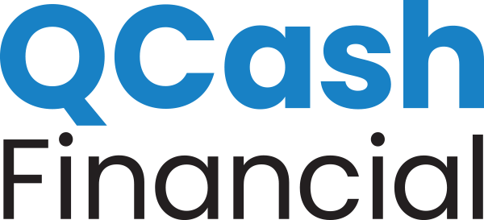
NEWS RELEASE

MEDIA CONTACT:
Erika Montgomery
Erika@ThreeGirlsMedia.com
408-218-2391

QCash Financial Announces Partnership with BCU to Introduce Express Loan

Provides Credit Union members an affordable short-term lending option

Olympia, Wash., March 1, 2021 – Headquartered in Vernon Hills, Illinois, BCU has introduced a new Express Loan, a new small dollar loan solution offering members short-term loans from $500 to $2,000 as an affordable and accessible option to help with unplanned expenses and short-term borrowing needs. Applying is quick and convenient, with a digital application process that provides loan approval and funding in minutes.

Using QCash Financial’s white-label, digital small dollar lending platform, Express Loan use the member’s relationship with the Credit Union to make a quick lending decision with no credit report required. Designed to additionally help members build and improve their credit scores, Express Loan offers a better solution to high-cost payday loans and other expensive borrowing options for a brighter financial future.

“BCU is committed to empowering our members to discover financial freedom,” said David Brydun, Vice President of Lending at BCU. “Together with QCash Financial, we are providing BCU members with a safe, affordable, and responsible loan solution for the challenges of real life.”

“BCU puts its members first in everything they do. Offering responsible lending products to manage the surprises that life hands all of us is an important tool in helping members to improve their financial well-being,” said Ben Morales, QCash Financial CEO. “We’re pleased to partner with the BCU team to support their member-first mission and help their members to grow in financial confidence at a time when it’s needed most.”

Learn more about BCU’s new Express Loan solution at BCU.org

About BCU
BCU is a purpose-driven organization that empowers people to discover financial freedom. With over $4.5 Billion in assets, it’s also one of the fastest growing credit unions in the last four decades. Both not -for-profit and member-owned, the Credit Union is driven by the commitment to provide extraordinary service for 300,000 members across the US and Puerto Rico. BCU members enjoy access to financial services and well-being programming that inspire confidence through the brand promise Here Today For Your Tomorrow. Lifetime membership is offered to employees and families of America’s best workplaces and those living or working in Chicago-area communities.

About QCash Financial
QCash Financial, headquartered in Olympia, WA, is a purpose-driven fintech firm with a mission of empowering financial institutions in their quest to improve the financial wellness of their communities. QCash Financial offers an automated, cloud-based, short-term lending technology and has recently launched a financial wellness app designed to build financial capacity, stability, and resilience.

